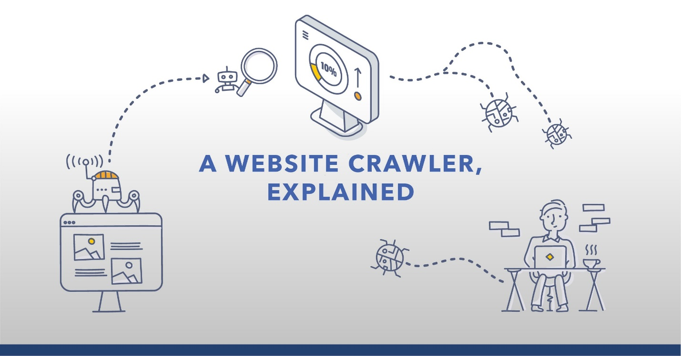

The Importance of a Crawler

**The organic search process can't be complete unless a crawler has access to your site**. Remember your goal as an SEO is to have your web pages rank on a search engine's results page. In order to be on the results page — in any rank position — a crawler needs to visit your site.

Why is crawling important in SEO?

So in order for your site to rank well in search results pages, it's important to make sure search engines can crawl and index your site correctly – **otherwise they will be unable to appropriately rank your website's content in search results**.

What is Web crawling in SEO?

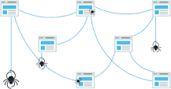

Crawling is **the discovery process in which search engines send out a team of robots (known as crawlers or spiders) to find new and updated content**. Content can vary — it could be a webpage, an image, a video, a PDF, etc.

In SEO, not all search engines are equal

Many beginners wonder about the relative importance of particular search engines. Most people know that Google has the largest market share, but how important it is to optimize for Bing, Yahoo, and others? The truth is that despite the existence of [more than 30 major web search engines](https://en.wikipedia.org/wiki/Web_search_engine), the SEO community really only pays attention to Google. **Why?**The short answer is that Google is where the vast majority of people search the web. If we include Google Images, Google Maps, and YouTube (a Google property), [more than 90%](https://moz.com/blog/state-of-searcher-behavior-revealed) of web searches happen on Google — that's nearly 20 times Bing and Yahoo combined.